Experiment No. 9

Experiment Title | Implementation of Association Rule Mining using Apriori Algorithm in Python
Course Outcomes | CO4: Implement appropriate data mining methods such as classification, clustering or frequent pattern mining on datasets.  CO5: Define and apply metrics to measure the performance of data mining algorithms.
Date of Preparation
Date of Submission
Signature & Grade
Name | Sahil Setya
Roll No. | 48

1. Aim
To implement the Apriori algorithm for Association Rule Mining in Python using the Music Streaming Subscriber Churn Dataset, identify frequent combinations of subscriber attributes, and generate association rules using support, confidence and lift.

2. Theory

2.1 Association Rule Mining
Association Rule Mining is a data mining technique used to discover relationships and patterns among items that occur together in a dataset. A rule is written in the form A → B, where A is called the antecedent and B is called the consequent. In this experiment, one subscriber record is treated as one transaction, and each categorical attribute-value pair is treated as an item. For example, a rule may indicate that subscribers from India with a churned status are associated with a particular subscription plan.

2.2 Apriori Algorithm
Apriori is a frequent pattern mining algorithm that discovers item combinations occurring in transactions with at least a specified minimum support. It begins by finding frequent single items and then forms larger candidate itemsets from the frequent itemsets already found. It uses the Apriori property: if an itemset is frequent, all of its non-empty subsets must also be frequent. Therefore, a candidate containing an infrequent subset can be pruned. After frequent itemsets are generated, possible association rules are evaluated using confidence, and rules meeting the minimum confidence are retained.

2.3 Measures
Measure | Formula | Meaning
Support | support(A ∪ B) = transactions containing A and B / total transactions | Shows how frequently the items in a rule occur together in the complete dataset.
Confidence | confidence(A → B) = support(A ∪ B) / support(A) | Shows the proportion of transactions containing A that also contain B.
Lift | lift(A → B) = confidence(A → B) / support(B) | Measures how much more often A and B occur together than expected if they were independent. Lift > 1 indicates a positive association.

3. Dataset and Tools
Dataset: Music Streaming Subscriber Churn Dataset.
The dataset contains 500 records and 10 attributes. For Apriori analysis, the following five categorical attributes were selected:
Categorical Attribute | Purpose in the analysis
subscription_plan | Subscriber's selected subscription plan
favorite_genre | Subscriber's favourite music genre
device | Device used by the subscriber
country | Subscriber's country
churn_status | Subscriber churn category/status
Each categorical value is converted into an item using one-hot encoding. The resulting transaction matrix represents whether an item is present in each subscriber record.
Tools: Python 3.15.2, Pandas, Matplotlib and Mlxtend.
Parameters: Minimum support = 0.05; minimum confidence = 0.50; maximum itemset length = 3; strong rules are selected using lift > 1.

4. Implementation

4.1 Load the Dataset
The dataset is loaded using Pandas. The first rows and dataset dimensions can be inspected to verify that the file has been read correctly.
import pandas as pd
import matplotlib.pyplot as plt
from mlxtend.frequent_patterns import apriori, association_rules

# Load the Music Streaming Subscriber Churn dataset
df = pd.read_csv("music_streaming_subscriber_churn.csv")

print("Dataset shape:", df.shape)
print(df.head())

4.2 Create the Transactions
The five selected categorical attributes are retained. Missing values, if present, are represented as a separate category so that the transaction matrix does not silently discard a record. One-hot encoding converts every distinct attribute-value pair into a Boolean item.
categorical_cols = [
"subscription_plan",
"favorite_genre",
"device",
"country",
"churn_status"
]

# Keep the categorical attributes used for association mining
items_df = df[categorical_cols].copy()

# Treat missing values as an explicit category
items_df = items_df.fillna("Missing").astype(str)

# Convert categorical values into transaction items
basket = pd.get_dummies(
items_df,
prefix=categorical_cols,
prefix_sep="=",
dtype=bool
)

print("Transactions:", len(basket))
print("Items:", basket.shape[1])
print(basket.head())

A transaction corresponds to one subscriber record. The encoded matrix is then supplied to the Apriori algorithm. The experiment output contains 500 transactions and 22 items.

4.3 Item Frequency
Item frequency is calculated by taking the mean of each Boolean item column. Since True represents presence in a transaction, the mean gives the support of that individual item. The ten most frequent itemsets are visualized in the generated graph.
item_support = basket.mean().sort_values(ascending=False)
print(item_support.head(10))

4.4 Apriori: Frequent Itemsets
The Apriori function is applied with minimum support 0.05 and maximum itemset length 3. The use_colnames option keeps the readable item names in the output.
frequent_itemsets = apriori(
basket,
min_support=0.05,
use_colnames=True,
max_len=3
)

frequent_itemsets = frequent_itemsets.sort_values(
by="support", ascending=False
)

frequent_itemsets.to_csv("frequent_itemsets.csv", index=False)
print("Frequent itemsets:", len(frequent_itemsets))
print(frequent_itemsets.head(10))

With the selected minimum support and maximum itemset length, the experiment generated 120 frequent itemsets. These itemsets contain combinations of one, two or three categorical items.

4.5 Association Rules
Association rules are generated from the frequent itemsets using confidence as the evaluation metric. The minimum confidence threshold is 0.50. The resulting rules are saved in a CSV file.
rules = association_rules(
frequent_itemsets,
metric="confidence",
min_threshold=0.50
)

rules = rules.sort_values(
by=["lift", "confidence"],
ascending=False
)

rules.to_csv("association_rules.csv", index=False)
print("Association rules:", len(rules))
print(rules[["antecedents", "consequents",
"support", "confidence", "lift"]].head(10))

A total of 81 association rules were generated using the specified confidence threshold.

4.6 Strong Association Rules
Strong association rules are selected by retaining rules with lift greater than 1. Such rules indicate a positive association between the antecedent and consequent. The selected rules are exported separately.
strong_rules = rules[rules["lift"] > 1].copy()
strong_rules = strong_rules.sort_values(
by=["lift", "confidence"],
ascending=False
)

strong_rules.to_csv("strong_association_rules.csv", index=False)

print("Strong association rules:", len(strong_rules))
print(strong_rules[["antecedents", "consequents",
"support", "confidence", "lift"]])

The strongest rule reported in this experiment is:
country=India AND churn_status=Churned → subscription_plan=Free
Confidence: 51.47%
Lift: 1.30
This rule indicates that, among transactions containing both country=India and churn_status=Churned, 51.47% also contain subscription_plan=Free. The lift value of 1.30 indicates that the consequent occurs more often with the antecedent combination than would be expected under independence.

4.7 Support against Confidence
A scatter plot is used to visualize association rules by plotting support on the horizontal axis and confidence on the vertical axis. Each point represents one rule, and its colour represents lift. This makes it possible to compare rule frequency, reliability and association strength in one graph.
plt.figure(figsize=(8, 5))
scatter = plt.scatter(
rules["support"],
rules["confidence"],
c=rules["lift"],
cmap="viridis"
)
plt.xlabel("Support")
plt.ylabel("Confidence")
plt.title("Association Rules: Support vs Confidence")
plt.colorbar(scatter, label="Lift")
plt.tight_layout()
plt.savefig("Experiment9_Graphs.png", dpi=300)
plt.show()

4.8 Top 10 Frequent Itemsets Graph
The ten most frequent itemsets are selected and plotted as a bar chart. The support value is used as the bar height. The graph helps identify the item combinations that occur most frequently in the subscriber transactions.
top10 = frequent_itemsets.nlargest(10, "support").copy()
top10["itemset_label"] = top10["itemsets"].apply(
lambda x: ", ".join(sorted(list(x)))
)

plt.figure(figsize=(10, 5))
plt.bar(top10["itemset_label"], top10["support"])
plt.title("Top 10 Frequent Itemsets")
plt.xlabel("Itemsets")
plt.ylabel("Support")
plt.xticks(rotation=45, ha="right")
plt.tight_layout()
plt.show()

4.9 Output Files
The implementation produces the following output files:
Output file | Description
frequent_itemsets.csv | Contains the frequent itemsets and their support values.
association_rules.csv | Contains the generated association rules and their support, confidence and lift.
strong_association_rules.csv | Contains the rules for which lift is greater than 1.
Experiment9_Graphs.png | Contains the generated visualizations for frequent itemsets and association rules.
The graph image supplied with the experiment is included below as a visual reference. The screenshot page contains the Top 10 Frequent Itemsets chart and the Support vs Confidence association-rule plot.
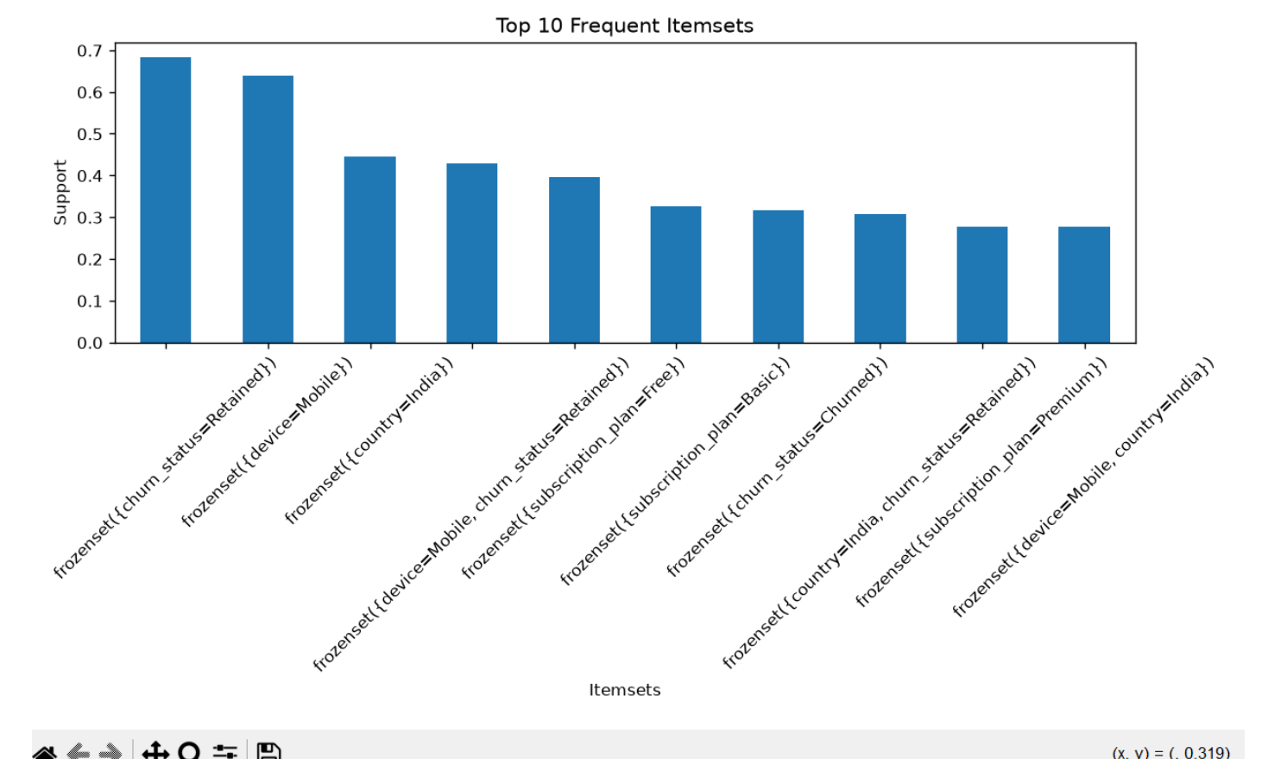
Figure 1: Top 10 Frequent Itemsets.
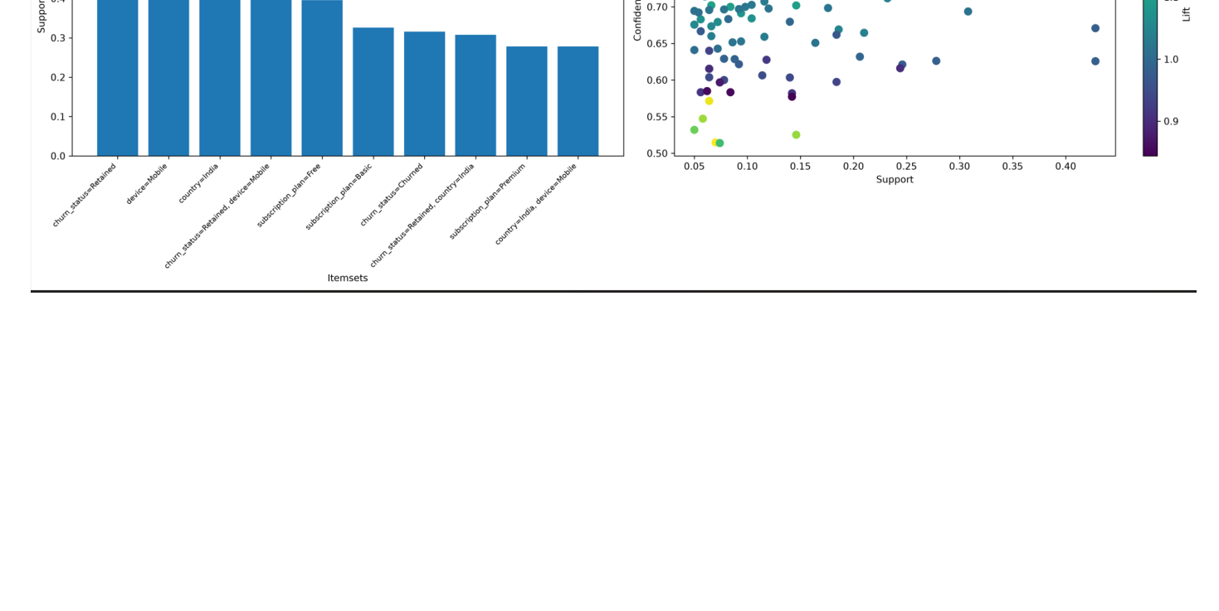
Figure 2: Top 10 Frequent Itemsets and Association Rules (Support vs Confidence, coloured by Lift).

5. Result Summary
Item | Result
Dataset | Music Streaming Subscriber Churn Dataset
Transactions | 500
Items | 22
Categorical attributes used | subscription_plan, favorite_genre, device, country, churn_status
Minimum support | 0.05
Minimum confidence | 0.50
Maximum itemset length | 3
Frequent itemsets | 120
Association rules | 81
Strong association rules (lift > 1) | 81
Software | Python 3.15.2, Pandas, Matplotlib, Mlxtend
Output files | frequent_itemsets.csv, association_rules.csv, strong_association_rules.csv, Experiment9_Graphs.png

Strongest Association Rule
Rule | Support | Confidence | Lift
country=India AND churn_status=Churned → subscription_plan=Free | Not separately specified | 51.47% | 1.30
Observation: All 81 generated association rules satisfy the strong-rule condition of lift greater than 1. The strongest reported rule connects subscribers from India with churned status to the Free subscription plan, with 51.47% confidence and a lift of 1.30.

6. Conclusion
The Apriori algorithm was successfully implemented in Python on the Music Streaming Subscriber Churn Dataset containing 500 subscriber records. Five categorical attributes were converted into 22 transaction items. Using a minimum support of 0.05, minimum confidence of 0.50 and maximum itemset length of 3, the algorithm generated 120 frequent itemsets and 81 association rules. All 81 rules had a lift greater than 1 and were therefore retained as strong association rules. The strongest reported rule was country=India AND churn_status=Churned → subscription_plan=Free, with 51.47% confidence and a lift of 1.30. The experiment demonstrates how association rule mining can reveal useful co-occurrence patterns in music streaming subscriber data.

